MANAGEMENT INFORMATION SYSTEM

ROSE JASMINE BINTI ALEXANDER

JANUARY 2025

MANAGEMENT INFORMATION SYSTEM

ROSE JASMINE BINTI ALEXANDER

A Project Report Submitted to the
College of Computing and Informatics
Universiti Tenaga Nasional
in Partial Fulfilment of the Requirements for the
Bachelor in Information Technology (Graphics & Multimedia) (Hons.)
JANUARY 2025

DECLARATION
I hereby declare that final year project is my original work except for quotations and citations have been duly acknowledged. I also declare that has not been previously and is not concurrently submitted for any degree program at Universiti Tenaga Nasional or at any other institutions. This final year project may be made available within the university library and may be borrowed, consulted, copied, or reproduced in accordance with the provision of the UNITEN Library Regulations from time to time made by the Library Committee.

ROSE JASMINE BINTI ALEXANDER
DC010100
DD/MM/YYYY

APPROVAL PAGE
This thesis entitled:
“MANAGEMENT INFORMATION SYSTEM”
submitted by:
ROSE JASMINE BINTI ALEXANDER (DC010100)
In requirement for the degree of Bachelor in Computer Science (Systems and Networking) (Hons.) College of Computing and Informatics, Universiti Tenaga Nasional has been accepted.
Supervisor: Prof. Dr. Salman Yussof
Signature: …………………….
Date: DD/MM/YYYY

ACKNOWLEDGMENT
On the Insert tab, the galleries include items that are designed to coordinate with the overall look of your document. You can use these galleries to insert tables, headers, footers, lists, cover pages, and other document building blocks. When you create pictures, charts, or diagrams, they also coordinate with your current document look.
You can easily change the formatting of selected text in the document text by choosing a look for the selected text from the Quick Styles gallery on the Home tab. You can also format text directly by using the other controls on the Home tab. Most controls offer a choice of using the look from the current theme or using a format that you specify directly.
To change the overall look of your document, choose new Theme elements on the Page Layout tab. To change the looks available in the Quick Style gallery, use the Change Current Quick Style Set command. Both the Themes gallery and the Quick Styles gallery provide reset commands so that you can always restore the look of your document to the original contained in your current template.

ABSTRACT
An abstract is a concise summary of a larger project that concisely describes the content and scope of the project and identifies the project’s objective, its methodology and its findings, conclusions, or intended results. As you are writing your abstract, stop at the end of every sentence and make sure you are summarizing the project you have undertaken rather than the more general topic. What should an abstract include? Every abstract should include four main types of information; It should state the main objective and rationale of your project, it should outline the methods you used to accomplish your objectives, it should list your project’s results or product (or projected or intended results or product, if your project is not yet complete), and it should draw conclusions about the implications of your project. Your abstract needs to be written in one long paragraph with maximum 300 words.

TABLE OF CONTENTS
Page
DECLARATION ii
APPROVAL PAGE iii
ACKNOWLEDGMENT iv
ABSTRACT v
TABLE OF CONTENTS vi
LIST OF TABLES ix
LIST OF FIGURES x
LIST OF SYMBOLS xi
LIST OF ABBREVIATIONS xii
CHAPTER 1 INRODUCTION 1
1.1 Project Backgound 1
1.2 Problem Statement 1
1.2.1 Developer Tab 1
1.2.2 Navigation Pane 2
1.2.3 Styles Pane 2
1.3 Objective 6
1.3.1 When you click Online Video, you can paste in the embed code for the video you want to add. 6
1.3.2 To make your document look professionally produced, Word provides header, footer, cover page, and text box designs that complement each other. 7
1.4 Scope 8
CHAPTER 2 LITERATURE REVIEW 12
2.1 Heading 1 12
2.2 Heading 2 12
2.2.1 Heading 3 12
2.2.2 Heading 3a 12
2.2.3 Heading 3b 14
2.3 Other important styles 14
2.4 Equations 17
2.5 Quote 17
CHAPTER 3 MATERIALS AND METHODOLOGY 19
3.1 Introduction 19
3.2 Heading 1 19
3.3 Heading 2 19
3.3.1 Heading 3a 19
3.3.2 Heading 3b 20
3.3.3 Heading 3c 20
3.4 Other important styles 20
3.5 Equations 20
3.6 Quote 21
CHAPTER 4 RESULT AND DISCUSSION 22
4.1 Introduction 22
4.2 Data pre-processing 22
4.2.1 Individual transformation 22
4.2.2 Row scaling 22
4.2.3 Column scaling 22
4.2.4 Mean centring 22
4.2.5 Standardisation 22
4.3 Exploratory data analysis 22
4.4 Variable selection 22
4.4.1 Multiblock methods in chemometrics 23
4.4.2 Multiblock similarity measures 23
CHAPTER 5 CONCLUSION AND RECOMMENDATIONS FOR FUTURE WORK 24
5.1 Introduction 24
5.2 Regression methods 24
5.3 Principal Component Analysis 24
REFERENCES 27
APPENDIX A SAMPLE APPENDIX 1 28
APPENDIX B SAMPLE APPENDIX 2 29

LIST OF TABLES
Table 1.1: Base and supplementary units in SI system. 8
Table 1.2: Derived SI units approved by the International General Conference on Weights and Measures (CGPM). 9
Table 1.3: Derived SI units approved by the International General Conference on Weights and Measures (CGPM). 10
Table 1.4: Sample of new table . 11
Table 2.1: Title 16
Table 2.2 Sample table The text in paragraph can be formatted using Table text style. On the other hand, the style for table’s caption is called Caption for Table UNITEN 18
Table 3.1 Sample table 21

LIST OF FIGURES
Figure 1.1: MZJ Ideas on formatting 1
Figure 1.2 Enabling the Developer Tab 2
Figure 1.3 Navigation Pane 2
Figure 1.4 Style Pane 3
Figure 1.5 Z Layout 5
Figure 1.6 One dotx for many docx 6
Figure 1.7 Enabling Styles Pane 7
Figure 1.8 Syles Pane on right side of the window 8
Figure 2.1: The RMSE plot for PLS and PCR models by using all descriptors on the three data split methods. 13
Figure 2.2 The atomic packing of a non-dense (random packing) materials. 14
Figure 3.1 Pore size distribution (PSD) of mesoporous materials. 19

LIST OF SYMBOLS
A | Number of PLS or PCA components in the model
a | Number of the PLS or PCA component
b | PLS regression coefficient
b | Number of blocks (b=1,2,3.....,K)
C | Coarse APM block
 | Pooled covariance matrix for the two classes

LIST OF ABBREVIATIONS
APM | Airborne particulate matter
BBB | blood-brain barrier
BMU | Best Matching Unit
CMB | Chemical Mass Balance
CPCA | Consensus PCA
CSI | Class Separation Indices
CSM | Class Sample Matrix
CSV | Class Sample Vector
CWM | Class Weight Matrix
CWV | Class Weight Vector
EDC | Euclidean Distance to Centriods

INRODUCTION

Project Backgound
Video provides a powerful way to help you prove your point. When you click Online Video, you can paste in the embed code for the video you want to add. You can also type a keyword to search online for the video that best fits your document.
To make your document look professionally produced, Word provides header, footer, cover page, and text box designs that complement each other. For example, you can add a matching cover page, header, and sidebar.

Problem Statement
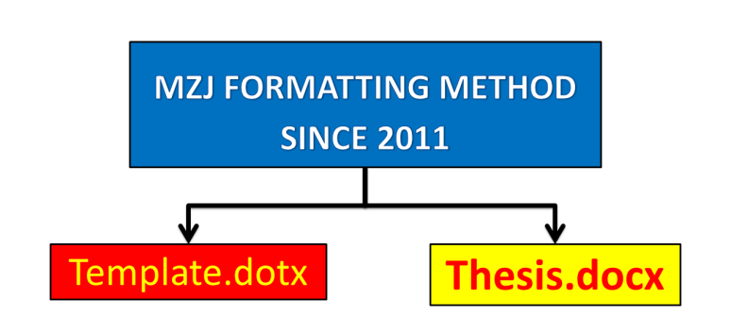
Figure 1.1: MZJ Ideas on formatting

Developer Tab
To create a new thesis based on this template, just double click the file. A new document will open in Microsoft Word, normally named Untitled.docx. You can start put your content in that file without having to worry about the thesis formatting. However, if you want to apply this dotx template to your current thesis, you need to enable the Developer Tab option. To do so, please refer to Figure 1.2.
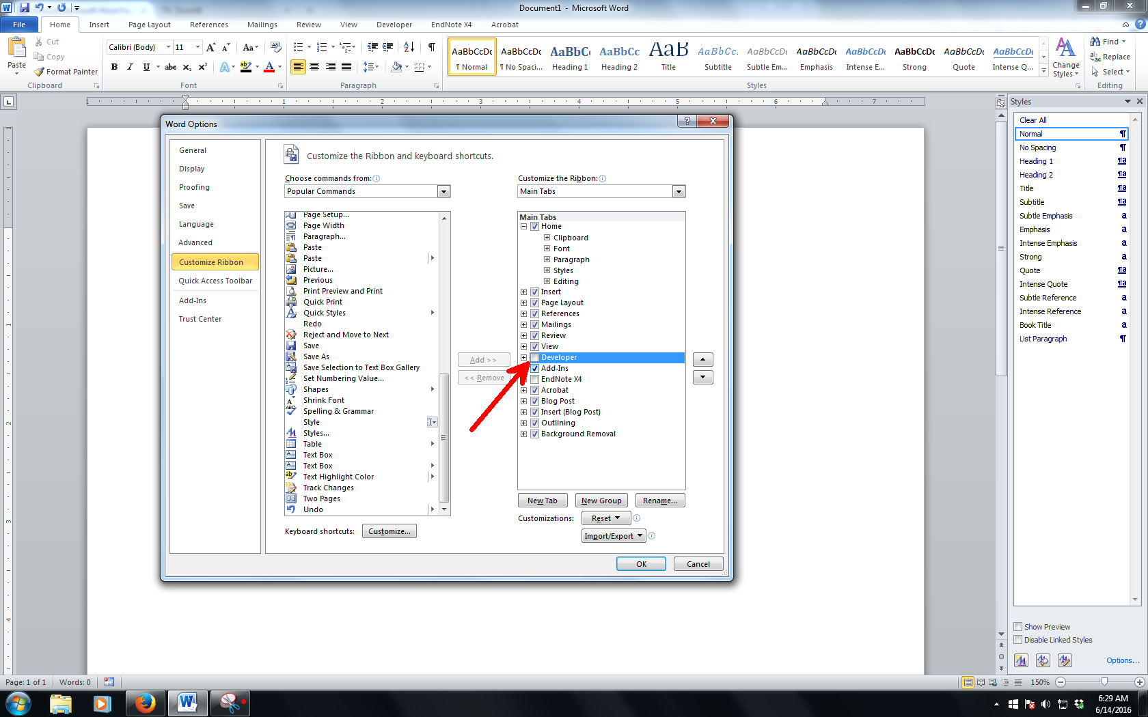
Figure 1.2: Enabling the Developer Tab
Source: Zuli (2016). Use style named Caption for text in Figure UNITEN for any text here.

Navigation Pane
Navigation pane is where you can browse through your thesis based on its heading name. To enable it, please refer to
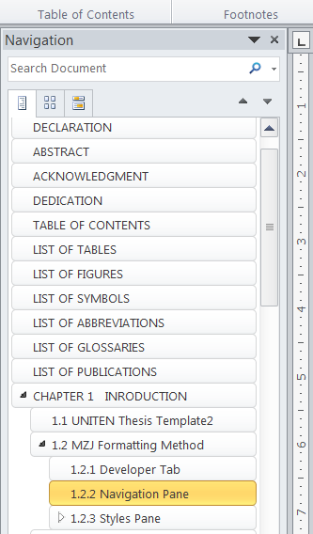
Figure 1.3: Navigation Pane

Styles Pane
The basic of applying template is using the styles on Style Pane (Figure 1.4) . Styles is predefined formatting of text and paragraph. It is most efficient that you put the Styles pane on the right side of the Microsoft Word working environment by click a small arrow as shown in Figure 1.7. If your pane is floating, click and hold the windows and put it at the right side of the windows.
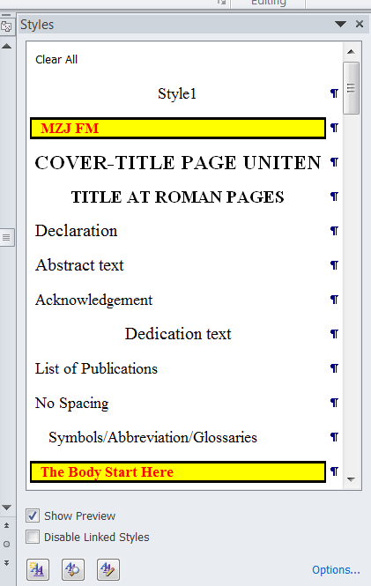
Figure 1.4: Style Pane

Quotation
A quotation which is inserted in a sentence must not be more than 40-words long and must always be written within inverted commas.
For example,
According to [4], “Ethical axioms are found and tested not very differently from the axioms of science. Truth is what stands the test of experience.”
For a quotation with more than 40 words, use the following style,
“On the Insert tab, the galleries include items that are designed to coordinate with the overall look of your document. You can use these galleries to insert tables, headers, footers, lists, cover pages, and other document building blocks. When you create pictures, charts, or diagrams, they also coordinate with your current document look”

You can easily change the formatting of selected text in the document text by choosing a look for the selected text from the Quick Styles gallery on the Home tab. You can also format text directly by using the other controls on the Home tab. Most controls offer a choice of using the look from the current theme or using a format that you specify directly.
“To change the overall look of your document, choose new Theme elements on the Page Layout tab. To change the looks available in the Quick Style gallery, use the Change Current Quick Style Set command. Both the Themes gallery and the Quick Styles gallery provide reset commands so that you can always restore the look of your document to the original contained in your current template”

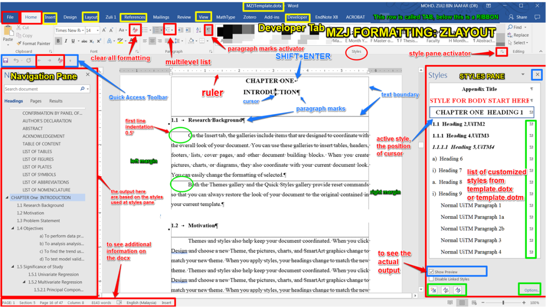
Figure 1.5: Z Layout

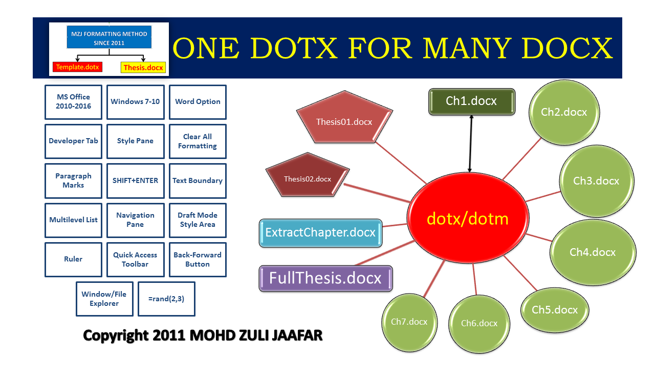
Figure 1.6: One dotx for many docx

Objective
On the Insert tab, the galleries include items that are designed to coordinate with the overall look of your document. You can use these galleries to insert tables, headers, footers, lists, cover pages, and other document building blocks. When you create pictures, charts, or diagrams, they also coordinate with your current document look. You can easily change the formatting of selected text in the document text by choosing a look for the selected text from the Quick Styles gallery on the Home tab.
You can also format text directly by using the other controls on the Home tab. Most controls offer a choice of using the look from the current theme or using a format that you specify directly. To change the overall look of your document, choose new Theme elements on the Page Layout tab. To change the looks available in the Quick Style gallery, use the Change Current Quick Style Set command.

When you click Online Video, you can paste in the embed code for the video you want to add.

Data Pre-processing and Exploratory Analysis by using PCA, SOMs and Class Separation Indices.

Multiblock methods and regression analysis of environmental dataset.

Pattern recognition in QSAR with the application of SOMs and PLSDA.

Data Splitting Methods for Regressions and Classifications.

You can also type a keyword to search online for the video that best fits your document.

To make your document look professionally produced, Word provides header, footer, cover page, and text box designs that complement each other.
For example, you can add a matching cover page, header, and sidebar.
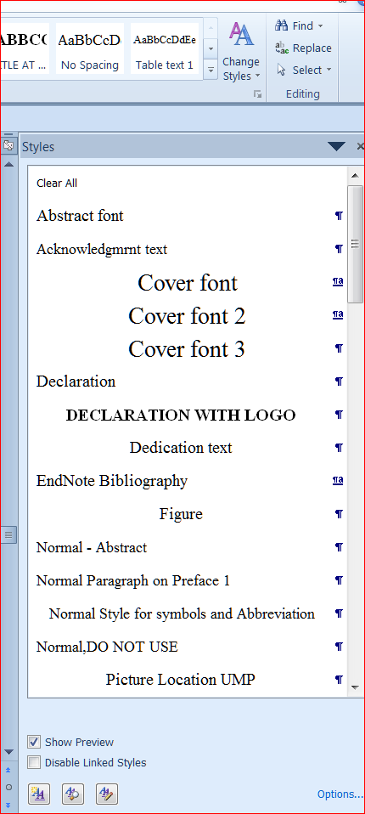
Figure 1.7: Enabling Styles Pane
Once secured on the right side of the working environment, the Styles Pane should look like Figure 1.8.
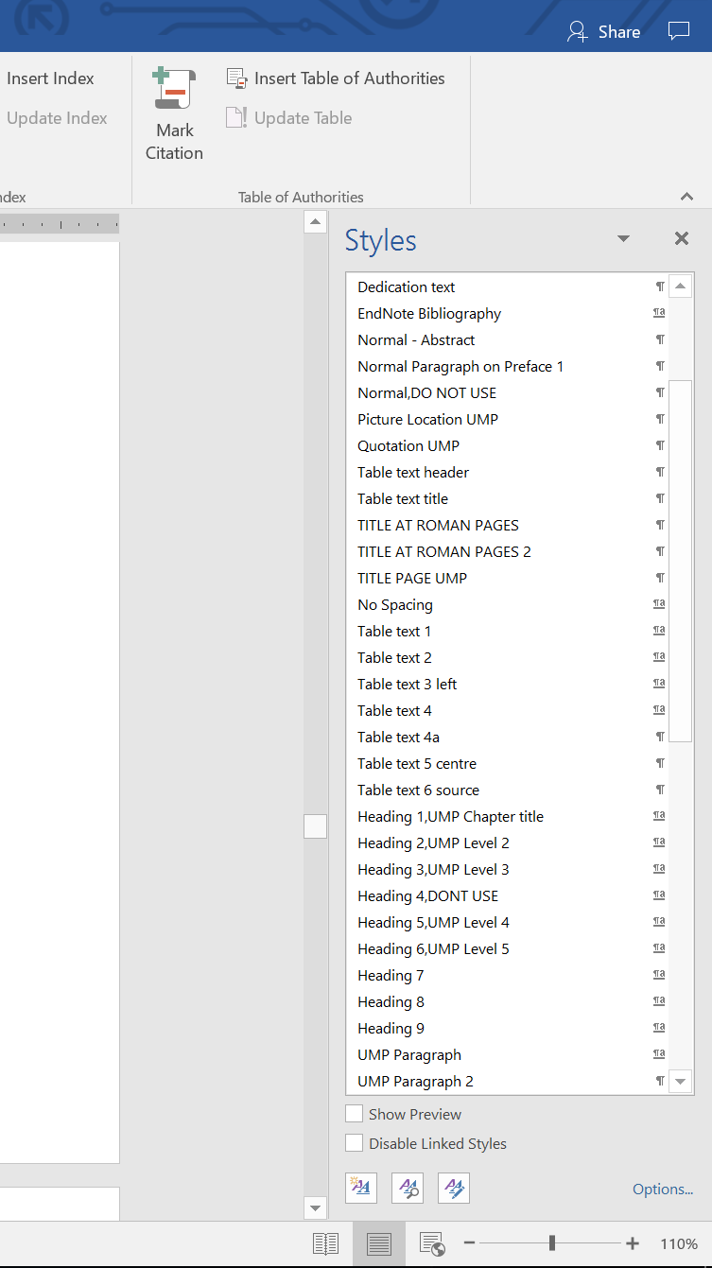
Figure 1.8: Syles Pane on right side of the window
This is just a simulation. Syles Pane on right side of the window Once the PC is ready, you can familiarize yourself with the styles in this template. Some of the styles will be explained in Chapter 2

Scope
Once the PC is ready, you can familiarize yourself with the styles in this template. Some of the styles will be explained in Chapter 2.Table 3.1 Sample tableTable 3.1
Table 1.1: Base and supplementary units in SI system.
Unit type | Quantity | Unit name | Unit symbol
Base units | Amount of substance | mole | mol
Base units | Electric current | Ampere | A
Base units | Length | Meter | M
Base units | Luminous intensity | Candela | Cd
Base units | Thermodynamic temperature | Kelvin | K

Table 1.2: Derived SI units approved by the International General Conference on Weights and Measures (CGPM).

Quantity | Unit name | Unit symbol | Formula
Absorbed dose | Gray | Gy | J/kg
Activity (of a radionuclide) | Becquerel | Bq | 1/s
Celsius temperature | Degree Celsius | °C | K
Dose equivalent | Sievert | Sv | J/kg
Electric capacitance | Farad | F | C/V
Electric conductance | Siemens | S | A/V
Electric resistance | Ohm | Ω | V/A
Electric potential, potential difference, electromotive force | Volt | V | W/A
Energy, work, quantity of heat | Joule | J | N•m
Force | Newton | N | kg•m/s²
Frequency (of a periodic phenomenon) | Hertz | Hz | 1/s
Illuminance | Lux | lx | lm/m²
Inductance | Henry | H | Wb/A
Luminous flux | Lumen | lm | cd•sr
Magnetic flux | Weber | Wb | V•s

Table 1.3: Derived SI units approved by the International General Conference on Weights and Measures (CGPM).
Title | Number | Student | Gendet | Income
Bold

Table 1.4: Sample of new table.
No | Item 1 | Item 2
1 | On the Insert tab, the galleries include items that are designed to coordinate with the overall look of your document. | On the Insert tab, the galleries include items that are designed to coordinate with the overall look of your document.
2 | You can use these galleries to insert tables, headers, footers, lists, cover pages, and other document building blocks. | You can use these galleries to insert tables, headers, footers, lists, cover pages, and other document building blocks.
3 | When you create pictures, charts, or diagrams, they also coordinate with your current document look. | You can easily change the formatting of selected text in the document text by choosing a look for the selected text from the Quick Styles gallery on the Home tab.

Project benefit

Gant Chart

LITERATURE REVIEW

Heading 1
Heading 1 is used for chapter naming. In this template, it is called Heading 1, UNITEN Chapter Title. In most cases, thesis will have around five to seven chapters.

Heading 2
The styles used for this subchapter 2.2 is Heading 2, UNITEN Level 2.

Heading 3
The heading for Subchapter 2.2.1 is formatted with Heading 3, UNITEN Level 3.

Heading 3a
Video provides a powerful way to help you prove your point. When you click Online Video, you can paste in the embed code for the video you want to add. You can also type a keyword to search online for the video that best fits your document.

- PCR models -SPXY | - PCR models - KS | - PCR-models - Duplex
- PLS models - SPXY | - PLS models - KS | - PLS models Duplex
Figure 2.1: The RMSE plot for PLS and PCR models by using all descriptors on the three data split methods.

Heading 3b
Video provides a powerful way to help you prove your point. When you click Online Video, you can paste in the embed code for the video you want to add. You can also type a keyword to search online for the video that best fits your document. To make your document look professionally produced, Word provides header, footer, cover page, and text box designs that complement each other. For example, you can add a matching cover page, header, and sidebar.
Click Insert and then choose the elements you want from the different galleries. Themes and styles also help keep your document coordinated. When you click Design and choose a new Theme, the pictures, charts, and SmartArt graphics change to match your new theme. When you apply styles, your headings change to match the new theme. Save time in Word with new buttons that show up where you need them.
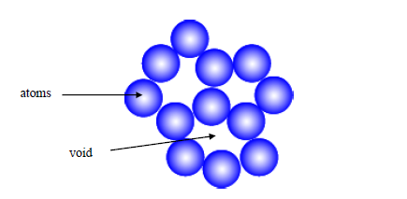
Figure 2.2 The atomic packing of a non-dense (random packing) materials.

Heading 4
In this template, Heading 4 is not used. Instead, the heading for level 4 will be using the Heading 5, UNITEN Level 4. That is all the heading styles needed to format a thesis.

Other important styles
All styles developed in this template are essential to a proper thesis formatting. The most widely used style is UNITEN Paragraph. This very paragraph is formatted by UNITEN Paragraph styles.

Table 2.1: List of Items and purpose
No | Item | Purpose
1 | PCA biplots | To show the influence of the variables on the samples. This plot is the combination of PCA scores and PCA loadings plot.
2 | Percentage of eigenvalues | To show the importance of each PCs. The percentage gives an indication about the variation of the data explained by each PC.
3 | PCA scores plots | To show the pattern or the distribution of the samples that may exist.
4 | PCA loading plot | To show the pattern or the distribution of the variable that may exist.
5 | 1D of first component scores plot | To support PCA scores plot of the samples’ distribution by using the highest percentage variances explained PCs

Another important one is the caption styles. All pictures in this template are formatted by using Caption for Equation styles.

Equations
As shown in all equations must be systematically numbered. To insert any equation, copy the whole equation and numbering below and paste on your desired location. After that, edit the equation. The style for equation is Caption for Equation UNITEN.
(Equation 2.1)
The paragraph after an equation of a figure, has to be formatted in UNITEN Paragraph 2. This is to allow some space between the paragraph and the equation or the figure’s caption. This paragraph is using UNITEN Paragraph 2 style.

Quote
To insert a quote like this, use Quotation UNITEN style. Please ensure all quotation are properly cited.
On the Insert tab, the galleries include items that are designed to coordinate with the overall look of your document. You can use these galleries to insert tables, headers, footers, lists, cover pages, and other document building blocks.
The text in paragraph can be formatted using Table text style. On the other hand, the style for table’s caption is called Caption for Table UNITEN.
Table 2.2 Sample table The text in paragraph can be formatted using Table text style. On the other hand, the style for table’s caption is called Caption for Table UNITEN
Test | Text
Test | Text
Test | Text
Test | Text
Test | Text

MATERIALS AND METHODOLOGY

Introduction

Heading 1
Heading 1 is used for chapter naming. In this template, it is called Heading 1, UNITEN Chapter Title. In most cases, thesis will have around five to seven chapters.
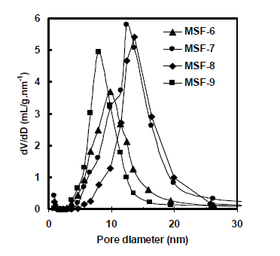
Figure 3.1 Pore size distribution (PSD) of mesoporous materials.

Heading 2
The styles used for this subchapter 2.2 is Heading 2, UNITEN Level 2.

Heading 3a
The heading for Subchapter 2.2.1 is formatted with Heading 3, UNITEN Level 3.

Heading 3b

Heading 3c

Heading 4
In this template, Heading 4 is not used. Instead, the heading for level 4 will be using the Heading 5, UNITEN Level 4. That is all the heading styles needed to format a thesis.

Heading 4
In this template, Heading 4 is not used. Instead, the heading for level 4 will be using the Heading 5, UNITEN Level 4. That is all the heading styles needed to format a thesis.

Other important styles
All styles developed in this template are essential to a proper thesis formatting. The most widely used style is UNITEN Paragraph. This very paragraph is formatted by UNITEN Paragraph syles.
Another important one is the caption styles. All pictures in this template are formatted by using Caption for Equation styles.

Equations
As shown in Equation Error! Reference source not found., all equations must be systematically numbered. To insert any equation, copy the whole equation and numbering below and paste on your desired location. After that, edit the equation. The style for equation is Caption for Equation UMP.
3.1
The paragraph after an equation of a figure, has to be formatted in UNITEN Paragraph 2. This is to allow some space between the paragraph and the equation or the figure’s caption. This paragraph is using UNITEN Paragraph 2 style.

Quote
To insert a quote like this, use Quotation UNITEN style. Please ensure all quotation are properly cited.
On the Insert tab, the galleries include items that are designed to coordinate with the overall look of your document. You can use these galleries to insert tables, headers, footers, lists, cover pages, and other document building blocks.
The text in paragraph can be formatted using Table text style. On the other hand, the style for table’s caption is called Caption for Table UNITEN.
Table 3.1 Sample table
Test | Text
Test | Text
Test | Text
Test | Text
Test | Text

RESULT AND DISCUSSION

Introduction

Data pre-processing

Individual transformation

Row scaling

Column scaling

Mean centring

Standardisation

Exploratory data analysis
Principal Component Analysis
Self Organizing Maps
Initialisation
Training
Class separation index
Silhouette width
Modified Silhouette width
Regression methods
Multivariate Linear Regression
Principal Components Regression
Partial Least Squares Regression

Variable selection

Multiblock methods in chemometrics

Multiblock similarity measures

Multiblock Partial Least Squares Regression

Data splitting methods

Data splitting for regression

Data splitting for classification

Classification methods
Partial Least Squares Discriminant Analysis
Supervised Self Organizing Maps
Data Pre-Processing and Data Drift: Exploratory Analysis and Class Separation Indices
Introduction
Dataset
Airborne particulate matter dataset
Meteorology dataset
QSAR dataset
Chemometrics Methods
Data pre-processing
Principal Component Analysis
Principal Component Regression
Principal Component Analysis, cluster separation indices and data drift
Self Organizing Maps
Results and Discussion
Airborne particulate matter dataset
Sample and elemental analysis
Exploratory data analysis by using Principal Component Analysis and Self Organizing Maps
Data pre-processing, PCA and class separation index
Meteorology dataset
QSAR dataset

CONCLUSION AND RECOMMENDATIONS FOR FUTURE WORK

Introduction
On the Insert tab, the galleries include items that are designed to coordinate with the overall look of your document. You can use these galleries to insert tables, headers, footers, lists, cover pages, and other document building blocks. When you create pictures, charts, or diagrams, they also coordinate with your current document look.
You can easily change the formatting of selected text in the document text by choosing a look for the selected text from the Quick Styles gallery on the Home tab. You can also format text directly by using the other controls on the Home tab. Most controls offer a choice of using the look from the current theme or using a format that you specify directly.
To change the overall look of your document, choose new Theme elements on the Page Layout tab. To change the looks available in the Quick Style gallery, use the Change Current Quick Style Set command. Both the Themes gallery and the Quick Styles gallery provide reset commands so that you can always restore the look of your document to the original contained in your current template.

Regression methods

Principal Component Analysis

Variable selection

PLS and PCR models by using all descriptors

Modelling at different empirical significant

Classification methods

Principal Component Analysis
Class Boundary Plot
Percentage Correctly Classified
Conclusions and Future Work

REFERENCES
Use reference manager such as Mendeley or Endnote to generate references list here.

APPENDIX A
SAMPLE APPENDIX 1
For Appendices Heading use TITLE AT ROMAN PAGES style.

APPENDIX B
SAMPLE APPENDIX 2
For Appendices Heading use TITLE AT ROMAN PAGES style.

